Narrative Text Structure

Story Line-Up
Objective
The student will sequence events in a story
Materials
- Pocket chart
- Sentence strips

Choose a familiar story and write the story title on a sentence strip.

Write four or more story events on sentence strips.
Activity
Students retell a story while sequencing sentences on a pocket chart.
- Place pocket chart and scrambled event sentence strips at the center.
- Working in pairs, students read the sentences and select the title strip. Place the title in the top pocket of the chart.
- Select the sentence strip that tells about the first event in the story, reread the sentence, and place in the next row of the pocket chart.
- Continue until all sentence strips are in sequential order.
- Read the sentence strips in order.
- Peer evaluation.
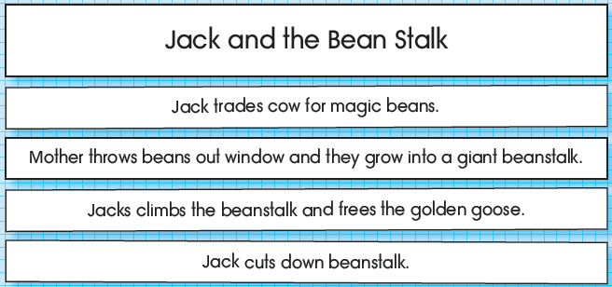
Extension and Adaptations
- Use other stories to make event sentence strips.
- Write a sentence and draw a picture that illustrates favorite event.
- Use a graphic organizer to depict events.

